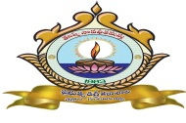 | GOVERNMENT DEGREE COLLEGE, CHEBROLE  Guntur District, Andhra Pradesh  (Accredited by NAAC with ‘B’ Grade)  Affiliated to Acharya Nagarjuna University  AISHE code: C-32624 website www.gdcchebrole.ac.in  Email: jkc.chebrole@gmail.com Pin 522 212 Phone No. 08644-254221
-----------------------------------------------------------------------------------------------------------------------------
2020-21
5.1.3 - Capacity building and skills enhancement initiatives taken by the institution include the following:
- Soft skills
- Language and communication skills
- Life skills (Yoga, physical fitness, health and hygiene)
- ICT/computing skills

In today’s world of cut throat competition individuals need to be physically fit, mentally strong and emotionally balanced. Students pursuing higher education need to be equipped with the skills that enable them face the challenges of the outside world boldly. Revised CBCS Curriculum (2020-21) prepared by the Andhra Pradesh State Council of Higher Education has made it mandatory for all the students pursuing higher education to undergo training in several Capacity Building and Skill Enhancement programmes since these are integrated with the curriculum with prescribed CREDITS
I. Soft Skills:
The curriculum prescribed for all UG courses under CBCS, Semester-I General English contains a unit on the Soft Skills with the following topics.
  - Attitude
  - Emotional Intelligence
  - Telephone Etiquette
  - Netiquette
  - Time Management

1. A 30 Hr Life Skill Course on ‘Human Values and Professional Ethics’ is mandatory for all the students of Semester-I with TWO credits
2. A 30 Hr ‘Life Skill Course” on ‘Personality Development’ is mandatory in semester-III with TWO credits
3. A 30 Hr ‘Life Skill Course’ on ‘Environmental Education’ is mandatory for all the Semester-III students with TWO credits
II. Language and Communication Skills. Most of the students belong to rural and uneducated background and possess insufficient communication skills. The Course Content of General English offered under Part-I for First, Second and Third Semester students is interactive and is skill oriented. Students are trained in Listening, Speaking, Reading and Writing Skills with the help of interactive exercises. Pair Work, Group Work, JAM sessions, Student Seminars
and Poster Presentations are conducted on a regular basis to enable students shed their inhibitions and become active users of English language. Work sheets are designed and assignments are conducted to promote reading and writing skills. Classroom teaching is augmented with British Council Videos and movies. The department of English has a collection of 200 story books which are distributed among the students to promote ‘Reading for Pleasure’.
A 100 hr training in Communication skills is offered to all the final year students under JKC which the Training and Placement unit of the college.

TRAINING AT GOVERNMENT DEGREE COLLEGE, CHEBROLE
GUNTUR DISTRICT, ANDHRA PRADESH.
TRAINING PERIOD:-25- 02 -2021 TO 03-03-2021
TRAINER NAME:-SK .MASTANBABU
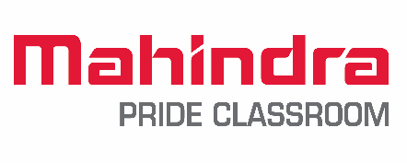

MPC Training on Employability skills Conducted at GOVERNMENT DEGREE COLLEGE (CHEBROLE) GUNTUR District Andhra Pradesh From 25-02-2021 to 03-03-2021 from the day Students participation is really great. Most of the students have come from economically poor background though their talents.
Day 1’sStarting introduction of Naandi and Mahindra Pride Class Room. After that I continue with the topic of THIS IS ME + I AM UNIQUE in this session students made their name cards very attractively also with a tagline related to them. After the stone activity students realized how unique they are from one another. They wrote their positive qualities and students felt very happy because their friends identified qualities.
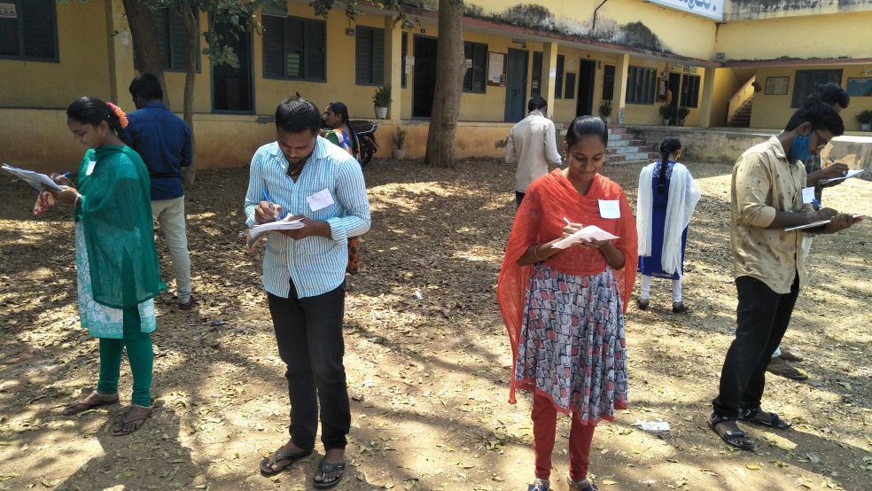
Second Session was Body Language Grooming and Hygiene in this session students got clarity about importance of first impression and after words them knowing about Grooming and Hygiene.
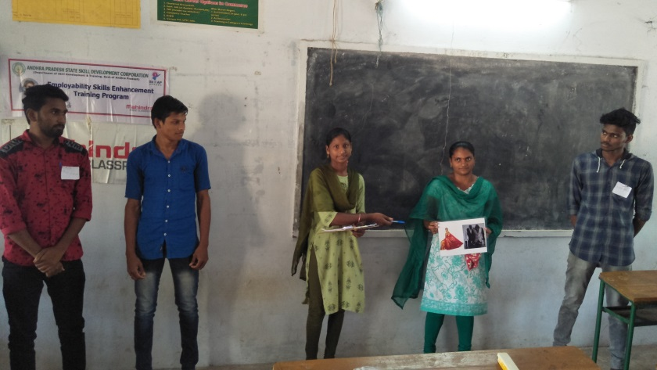
Third session was Time Management in this session students are very active while preparing the expanses sheet and they realized how they are wasting their time what is importance of each second and also they learned the importance of priority matrix
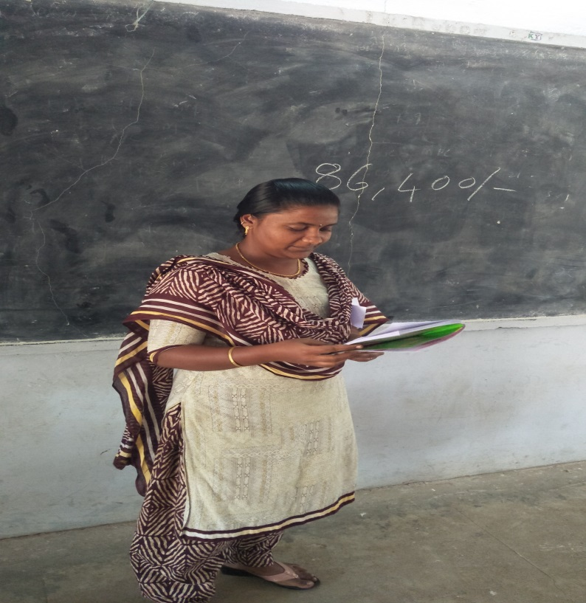
Day :-2 First session was Point of View in the Starting of the session show the images of the optical illusion students found that different pictures they enjoy lot and afterwards form a 8 groups each group given a topic one group for and another group against their said that point of view end of this session students learn how to talk inform of their share their views and ideas.
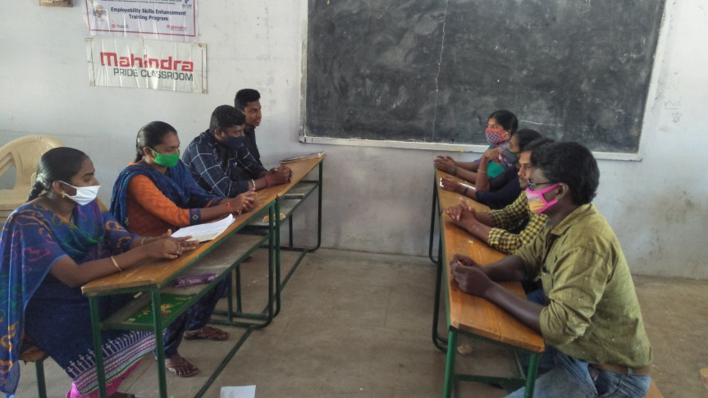
Second session was Kindness Boomerang in this session shown images of Boomerang and video students realized from this video when they do good always come back and each group given presentation about Nature and Environment.
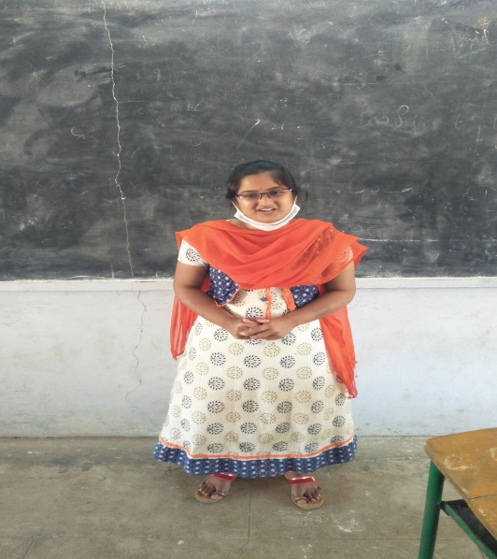
Third session Story Telling in this session all the students kept their creativity and divided the groups given picture card and after that their started seeing the pictures own creativity and their thoughts, ideas, views, they discussed with group members in front of the friends given story explanation finally end of the session they not having any stage fear I am so happy.
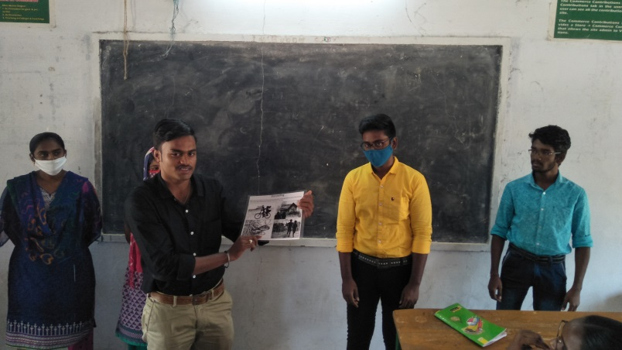
Day :-3 First session was Interview Preparation in this session all the students had introduced to prepare their own Resume and interview tips after that the session they all know how to prepare answer interview questions for beginners.
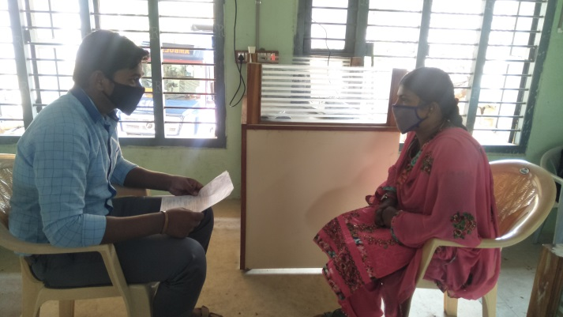
Second session was Money Management in this session through expenses tree activity students came to know the income verses expenses and value of savings for unexpected expenses.
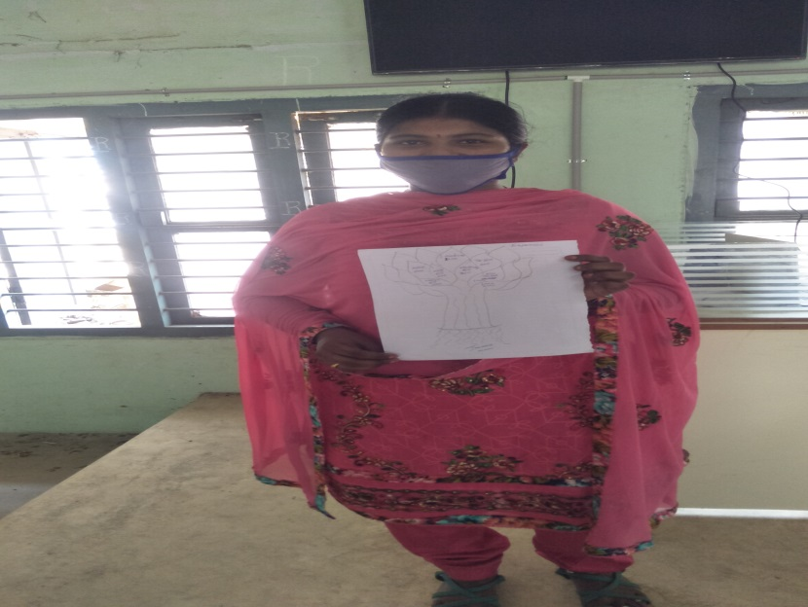
Day :- 4 Today my first session was Group Discussion in this session students learned how to participate in Group Discussion and they observed that what the points are considered in GD
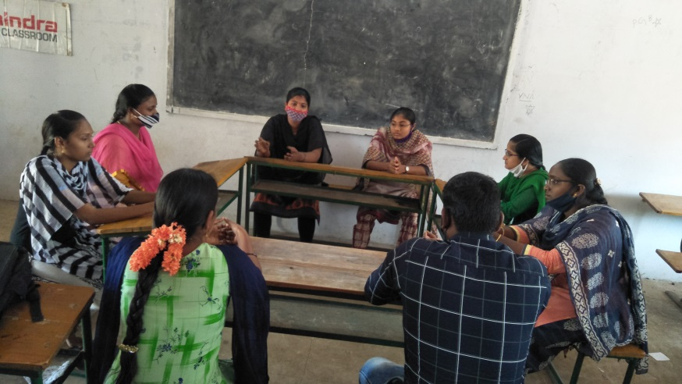
Second session was Goal setting in this session students tried to make paper boxes, after they watch the video how to make paper boxes with the help of that video students actively participated in making paper boxes. Students wrote their goals on goal setting paper and they mark their positions in wheel of life finally they realized that they want to goal in life.
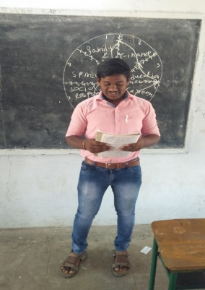
Third session was Extempore Speech (Basic) in this session every students given speech on topic they confidence in public speaking.
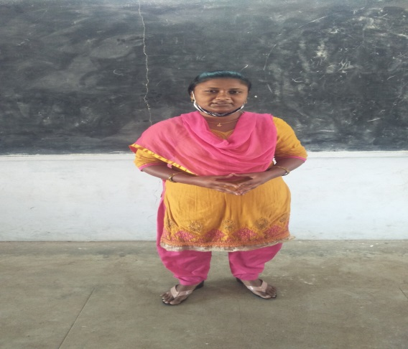
Day :-5 First session was Professional Ethics in this session students learn about character and Behavior and they did activity of six pillars. They realize that they have to be responsible person.
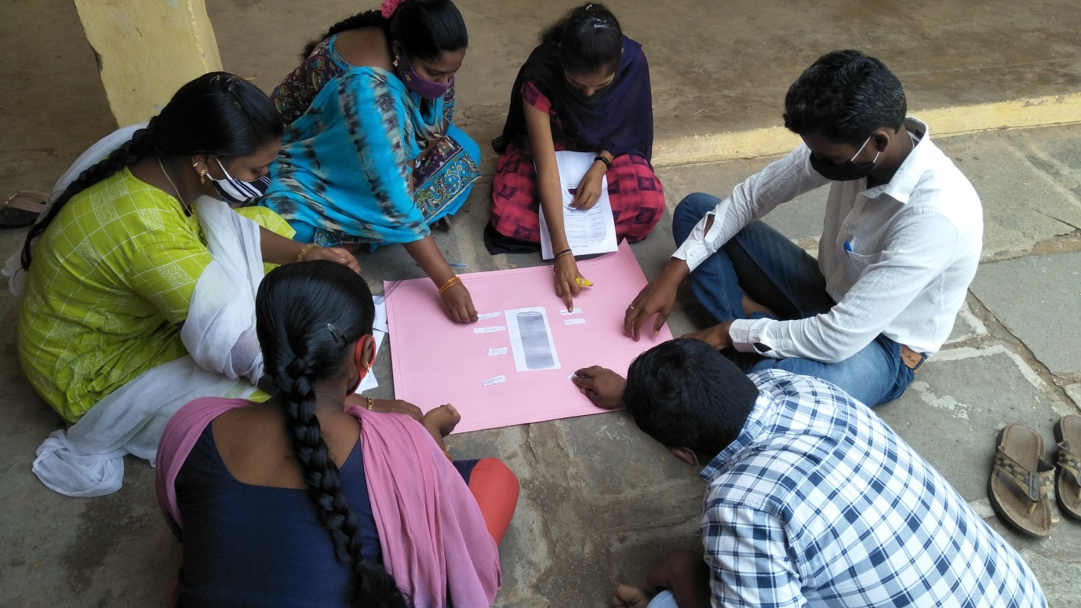
Second session was I am Limitless in this session I started I am limitless the session the end of the session I asked students how many of you ready to willing to relocate all the students are raised their hands I think this class went good that’s so many students are willing to relocate.
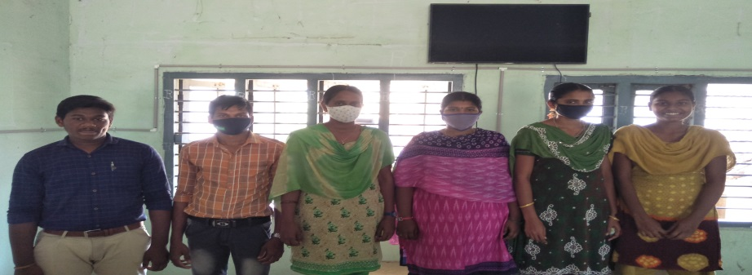
Day :- 6 Today my session was Mock Interview in this session students have participated in Mock Interview and they got knowledge about how Mock Interviews will be conducted.
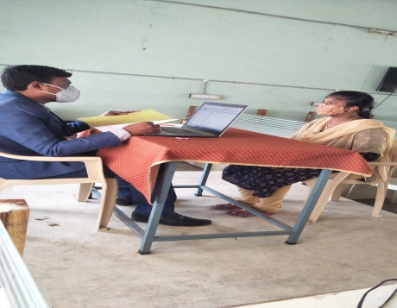
Second session Spreading Happiness in this session shown video Ubuntu, Joy of sharing, deepika padukone and smile video finally they understood joy of sharing.
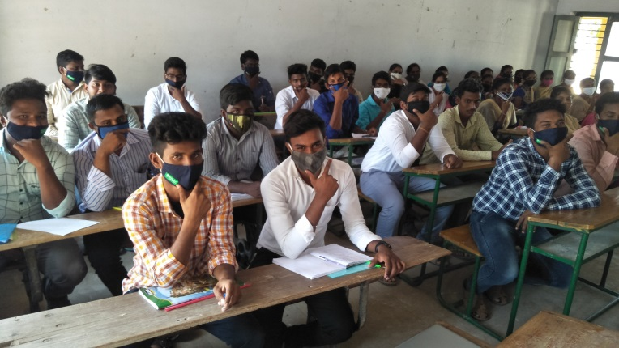
Group Photo
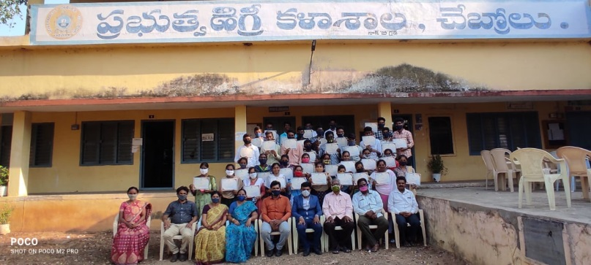

CERTIFICATE DISTRIBUTION

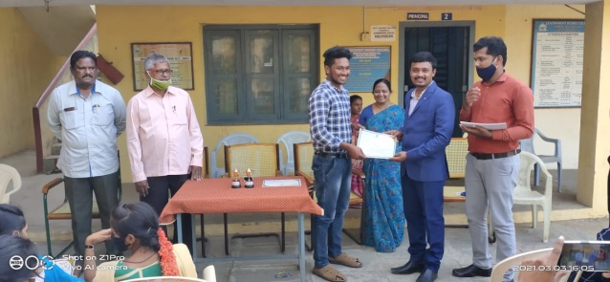

III. Life Skills (Yoga, Physical Fitness, Health and Hygiene)
Yoga is an every- day programme in this institution. Physical fitness is given utmost importance with three hours in a week being allotted to sports.
International Yoga Day

YOGA DAY
21-06-2021

our college International Yoga Day has been conducted by NSS Unit. 30 students and staff were participated in this programme.
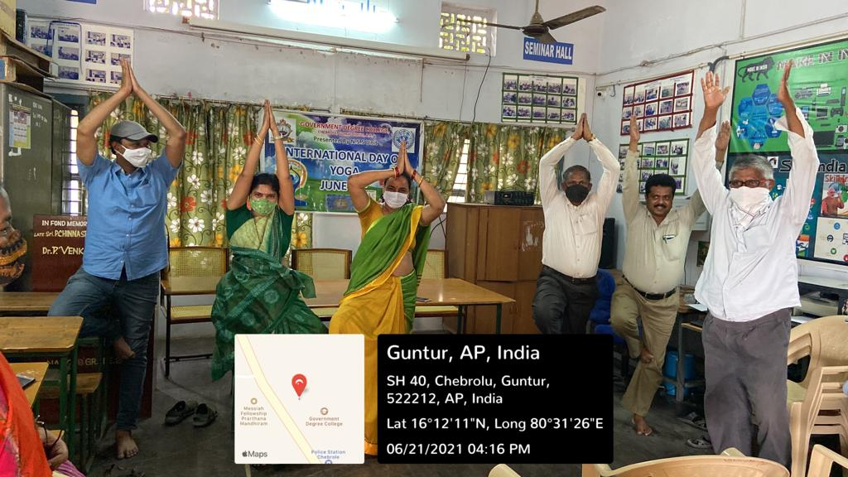

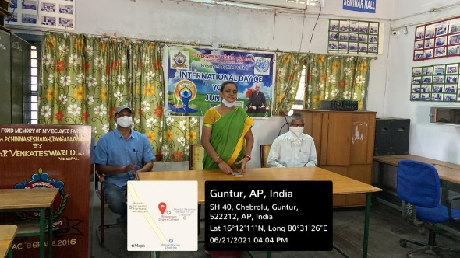
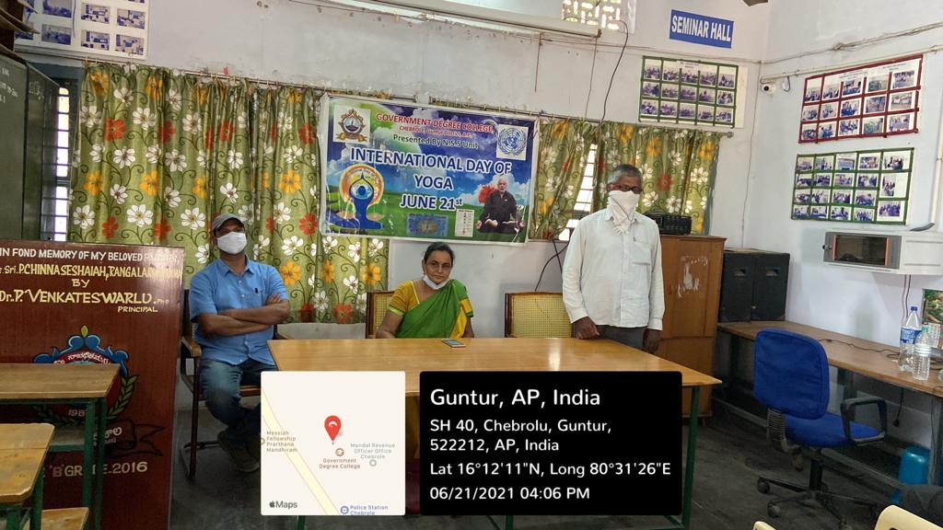

COVID-19 AWARENESS PROGRAM
16-04-2021

Dr.T.Vani, Ayush Medical Officer, Govt. Ayurvedic Dispensary, Brahmana Koduru has visited the college and given awareness about covid-19 and distributed ‘chyavan prash’ to all students and staff .

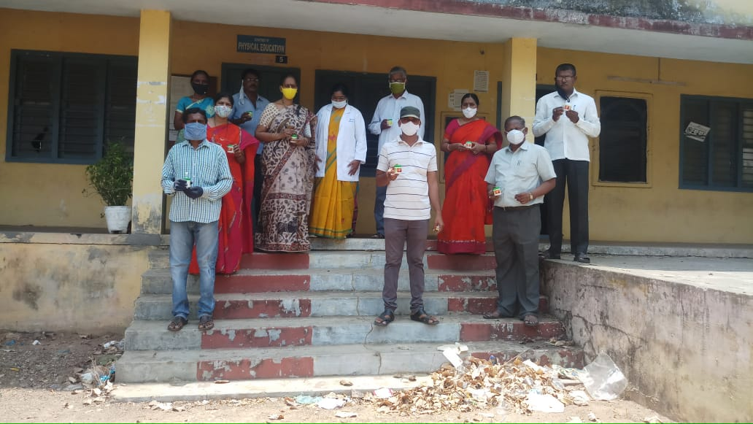

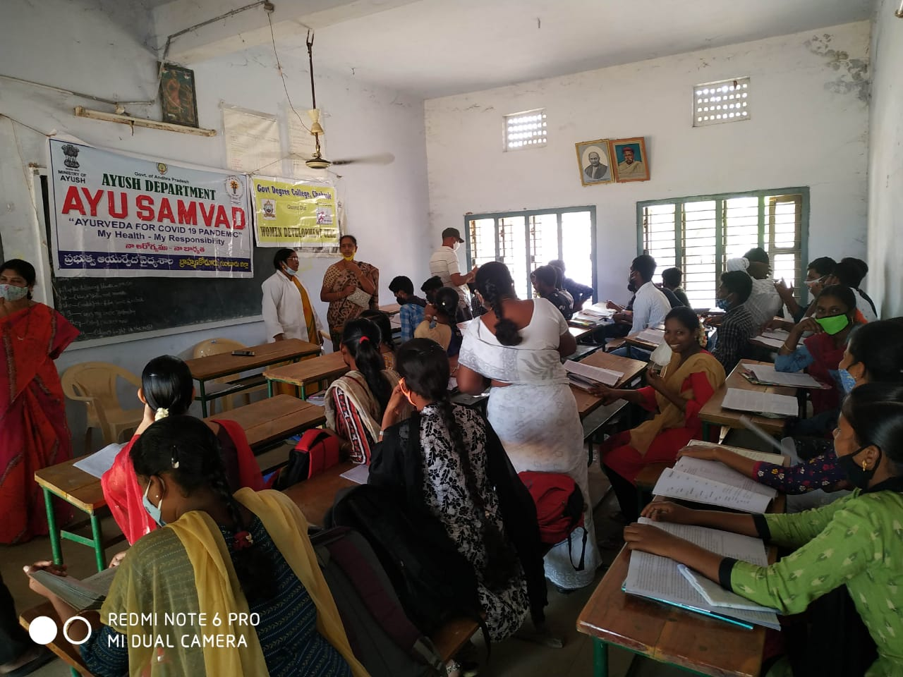

Health and Hygiene programme
7-12-2021
Women Empowerment Cell GDC, chebrole organized a programme on women health issues and gynecological problems. Dr. K. Sireesha gave suggestions to the students on hygienic and balanced diet. All lady staff and 35 girl students participated in this programme.
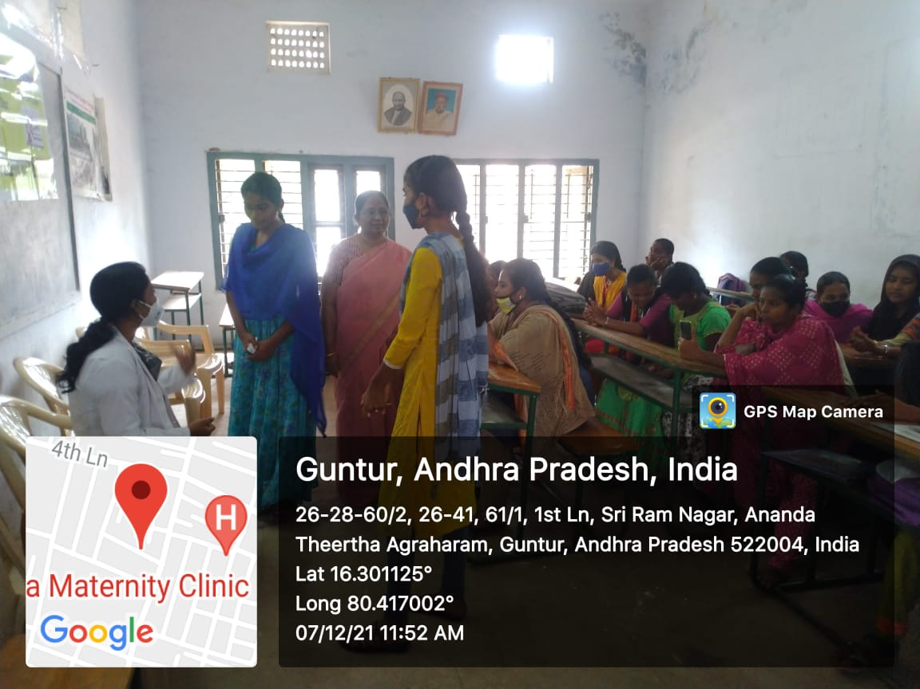

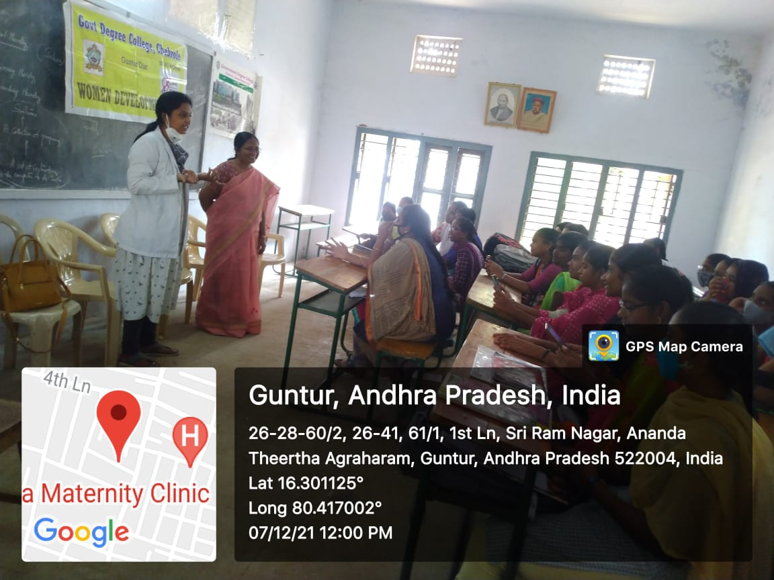

-x-x-x-x-x-x-

