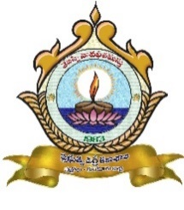 | GOVERNMENT DEGREE COLLEGE CHEBROLE  Guntur District, Andhra Pradesh, Pin 522212  Affiliated to Acharya Nagarjuna University  Email: jkc.chebrole@gmail.com Phone No. 08644-254221 | 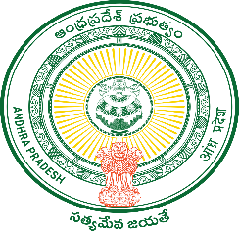
=====================================================================================

OUR VISION

To provide and promote quality education with necessary etiquette, behavioural skills, life skills and employability skills to students aspiring higher education who are mostly from impoverished and marginalized first generation families of surrounding villages. The students will be encouraged to identify their talents and to develop their talents for the betterment of the students and the society at large.

OUR MISSION

The vision is translated as mission through

- Student – centred and experiential teaching – learning methods to foster creative and critical thinking skills.

- Imparting of etiquette, behavioural skills, life skills and job skills for employability and global citizenship by creating necessary ambience.

- Transparent and honest governance, team spirit and collective effort. We strive to link what is learned in classroom to the world at large enabling students to take right attitude and spirit.

